**Assignment 14 : Group C (Unit V & VI )**

|  |  |  |  |  |  |  |
| --- | --- | --- | --- | --- | --- | --- |
| **W (4)** | **C (4)** | **D (4)** | **V(4)** | **T (4)** | **Total** | **Sign** |
|  |  |  |  |  |  |  |

**Date of Performance ____________**

**Date of Completion** :_____________

**Problem Definition:** Study and Analyze the performance of HTTP, HTTPS and FTP protocol using Packet tracer tool.

The File Transfer Protocol (FTP) is a standard network protocol used for the transfer of computer files between a client and server on a computer network.

FTP employs a client-server architecture whereby the client machine has an FTP client installed and establishes a connection to an FTP server running on a remote machine. After the connection has been established and the user is successfully authenticated, the data transfer phase can begin.

Worth noting: Although FTP does support user authentication, all data is sent in clear text, including usernames and passwords. For secure transmission that protects the username and password, and encrypts the content, FTP is often secured with SSL/TLS (FTPS) or replaced with SSH File Transfer Protocol (SFTP).

Let’s now do FTP configuration in Packet Tracer:

1.Build the network topology.

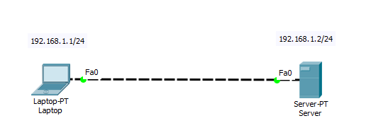

FTP topology.PNG

2. Configure static IP addresses on the Laptop and the server.

Laptop: IP address: 192.168.1.1 Subnet Mask: 255.255.255.0

Server: IP address: 192.168.1.2 Subnet Mask: 255.255.255.0

3. Now try using an FTP client built in the Laptop to send files to an FTP server configured in the Server.

From the Laptop’s command prompt, FTP the server using the server IP address by typing: ftp 192.168.1.2

Provide the username(cisco) and password(cisco) [which are the defaults] for ftp login.

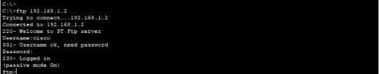

ftp from laptop.PNG

You are now in the FTP prompt .

PC0 has an FTP client which can be used to read, write, delete and rename files present in the FTP server.

The FTP server can be used to read and write configuration files as well as IOS images. Additionally, the FTP server also supports file operations such rename, delete and listing directory.

With that in mind, we can do something extra. So let’s do this:

4. Create a file in the Laptop then upload it to the server using FTP.

To do this, open the Text Editor in the Laptop, create a file and give it your name of choice.

Type any text in the editor then save your file. e.g. myFile.txt.

5. Now upload the file from the Laptop to the server using FTP. (An FTP connection has to be started first. But this is what we’ve done in step 3)

So to do an FTP upload, we’ll type:

put MyFile.txt

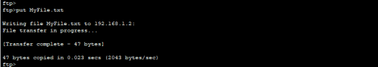

put MyFile to FTP directory.PNG

6. Once file upload is successful, go to the Server FTP directory to verify if the file sent has been received . To do this, go to Server-> Services->FTP. Here look for MyFile.txt sent from the laptop.

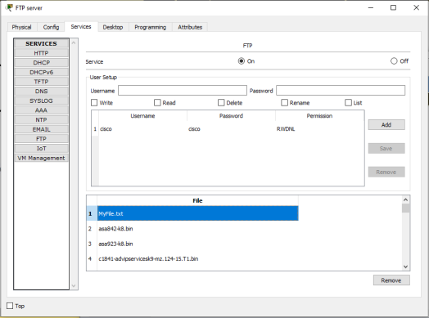

MyFile.txt really send to sever.PNG

Something extra: To check other FTP commands supported by the FTP client running on the Laptop(or PC), you can use a question mark (?) on the Laptop’s command prompt as shown below:

All FTP commands supported

You can see the put command that we used to upload our file to the FTP server. Other commands listed include:

get-used to get(download) a file from the server.

For example: get MyFile.txt

delete– to delete a file in the FTP directory with the server

For example: delete MyFile.txt

Rename– used to Rename a file

cd – used to change directory.

For example, we can open an HTTP directory in the server by typing: cd /http. This will change the current directory from FTP directory to HTTP directory

Once the http directory is open, you can upload a file to the HTTP server. You’re now uploading a file to an HTTP folder(directory) using FTP.

For example: put MyFile.txt

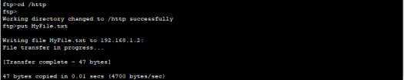

To see this working, let’s open an HTTP directory and upload(put) a file to it using FTP:

changing directory then put files to HTTP directory using FTP

You can now check up in the HTTP directory in the server and verify that the file uploaded from the Laptop(MyFile.txt) is well received:

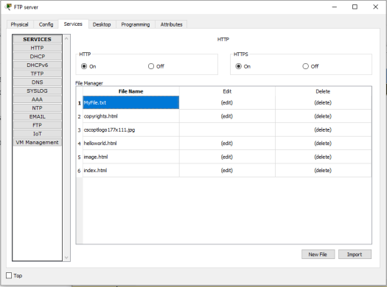

MyFile.txt really send to HTTP server

Notice that we are uploading files to an HTTP Server directory using File Transfer Protocol.(FTP). This is what actually happens when you use an FTP client such as FileZilla client to upload files to a website. In our case here, we are using an FTP client built-in the Laptop.

This may interest you: The first FTP client applications were command-line programs developed before operating systems had graphical user interfaces, and are still shipped with most Windows and Linux operating systems. (Actually this is what we have been using this far). Many FTP clients(e.g. FileZilla) and automation utilities have since been developed for desktops, servers, mobile devices, and hardware. FTP has also been incorporated into productivity applications, such as HTML editors.

We’ll create an html file in our Laptop, upload it to HTTP server directory using FTP, then try to access the file from the Laptop’s browser.

On the Laptop, open the text editor, then type some markup(html) and save the file with the extension .html. See all this below:

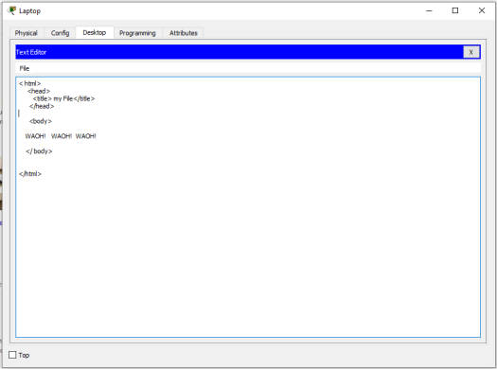

File2 HTML code

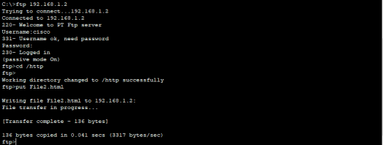

Save your file as an html file like this:

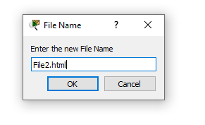

File2 html.PNG

Now upload the file( File2.html) to the HTTP server using FTP. This is easy. We’ve already done it previously!

If you’re already in the HTTP directory, you just need to type: put File2.html. If no, first ftp the server(ftp 192.168.1.2), provide the login username(cisco) and password(cisco); change the current directory to HTTP(cd /http) , and finally upload the html file onto the HTTP directory(put File2.html)



Sending File2. html to HTTP directory.PNG

Check whether the html file uploaded has been received in the HTTP directory:

Go to Server->Services-> HTTP. Then look up for the file in the File Manager.

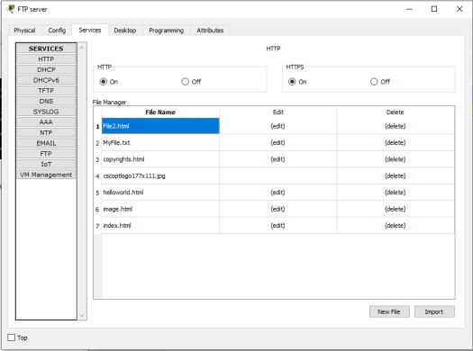

File2 HTML really uploaded into HTTP directory.PNG

Now edit index.html file in the HTTP directory so as to include a link to File2 that we’ve just uploaded. This will make File2 accessible from the Laptop’s browser. To do this, locate index.html then click edit. Proceed to edit it as shown below. Then save and accept overwrite.Index.html editing to include File2 html.PNG

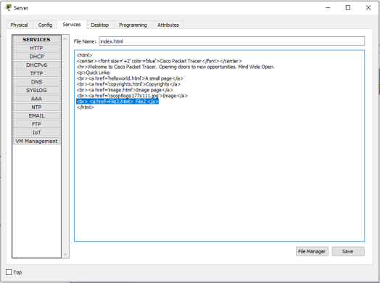

Finally, try to access the newly uploaded file from the Laptop’s browser.

So go to the Laptop’s browser and access the server using the server’s IP address. By doing this, the browser is making an http request to the server. The server will respond to the Laptop with the index.html file containing a link to File2 which we’ve uploaded from the Laptop using FTP.

Http response with File2.PNG

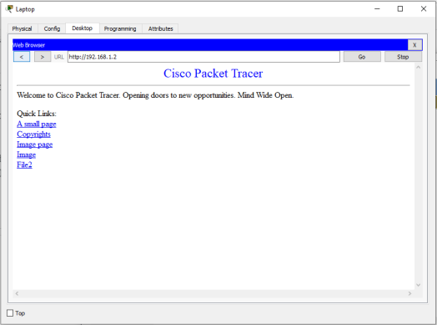

Click File2 link to view the contents of the file in the browser.

**Assignment Questions:**

1. What Is Ftp?How To Deny Specific Users Access To The Ftp Server ?

2. Can We Create Logs For Ftp Authenticated Sessions?

3. Describe The Different Roles Of Http?

4. What Are Response Codes In Http?

5. What information does HTTPS protect?

6. What Are Status Codes In Http?